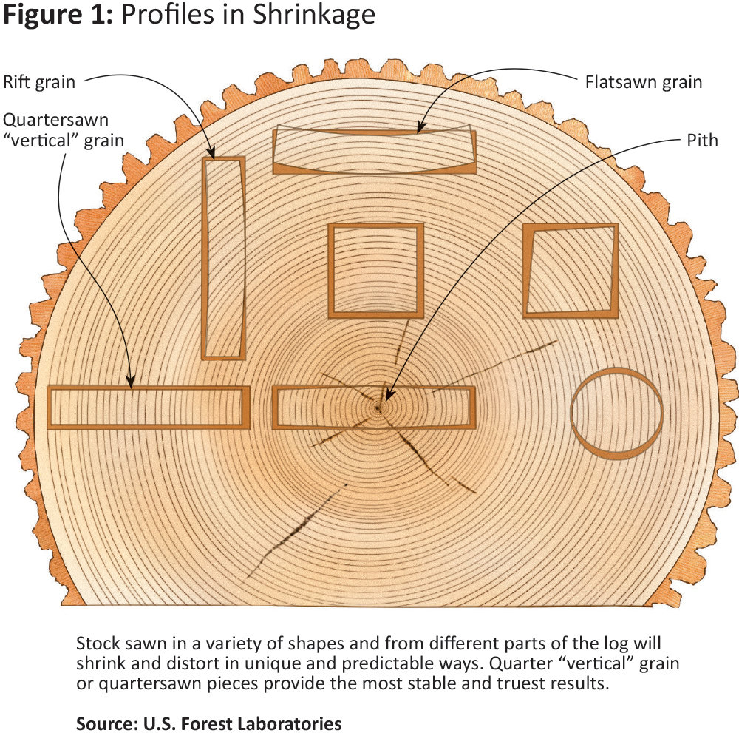

On a prepared S4S board, Surfaced-4-Sides, the Face is the wider dimension and the Edge is the narrower dimension, typically.

Plain sawn or Flatsawn – Fastest most affordable way to produce lumber. Grain is tangential to the face, more prone to deforming. Produces a “cathedral” shaped pattern on the face. Figure 2 – 2.1.
End grain in Figure 2 -2.2. Other terms: live sawn, through and through.

Vertical grain or Straight grain - Grain is continuously parallel to the board’s edge, along the length. End grain is less than 90° to sawn face, top figure 2 - 2.2, below. No flakes of Medullary rays visible, vertical grain only. Other terms: VG, comb grain, rift (Oaks).

Quartersawn - End grain direction is 90°, perpendicular, to sawn face, middle figure 2 – 2.2. Most prominent in Oaks. Figure is generated by revealing the length of the medullary rays, rather than a cross section.

Medullary rays – imagine a spoked wheel as a horizontal slice cut through a tree. Laying the wheel on its side, the rim represents bark. The spokes are the Medullary rays, radiating out horizontally from the center of the wheel or tree. Quartersawn boards expose the rays’ structure (like slicing a straw in half, length ways) on the vertical grain.

Figure 2 - 2.1
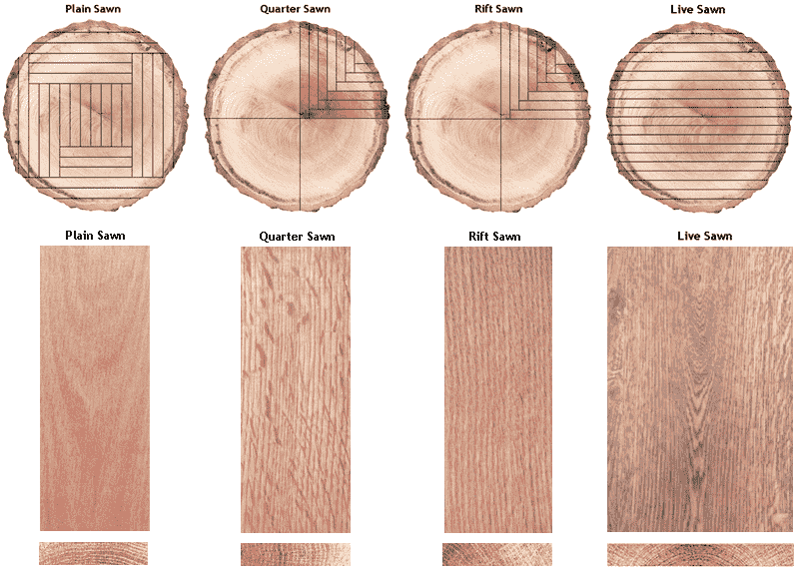
Sawn face of board
End grain of board
End grain of tree

Figure 2 – 2.2
